**Week 06**

**Forms**

Form is part of the one collection HTML, which in turn is composted by elements, and it's possible to access the form through: ***document.forms*** and/or elements through: ***form.elements***

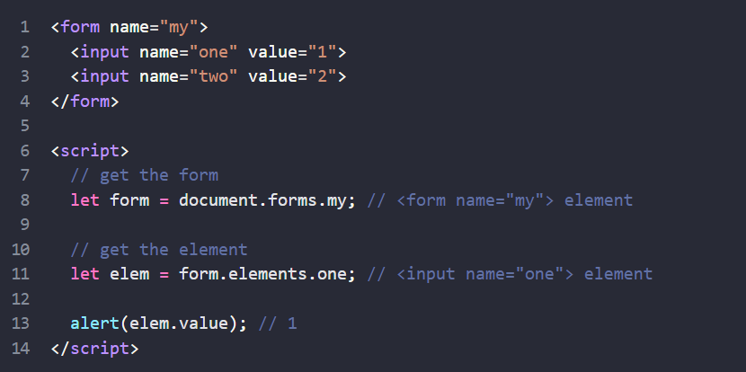

HTML Collection are objects and in the syntax above behave as one array, it has length proprieties and can be indexed by name and number/position.

Representation the relationship between forms and elements:

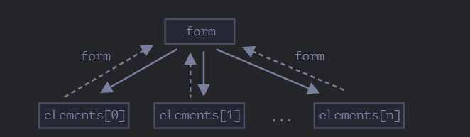

The way accesses the value from element can be different, input can use *input.value* to string or *input.checked* to boolean(checkbox and radio).

Already the select's element has: *select.options*, *select.value* and *select.selectedIndex*

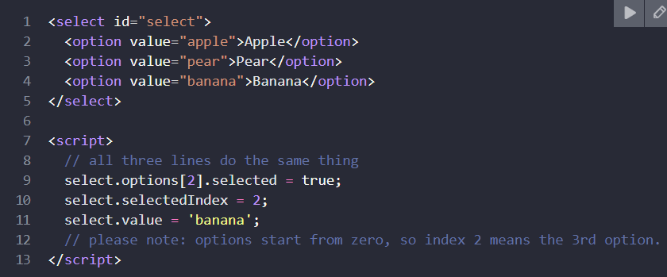

The main purpose the forms is collect information and send for server, the method *form.submit()* has the function to send and allows us the two way: by *click* (using <input type="submit"> or <input type="image">) or *press an input field*. When checking the submit if here are errors, show them and call *event.preventDefault().*

What will be sent from a form can be manipulated, **FormData** is an object that helps us with this, and has some methods that help us with this manipulation:

* FormData.append()- which can add name, value, fileName;
* formData.delete() - remove the passed element;
* formData.get() - get the value;
* formData.has() - check if the element exists and returns a boolean value;
* formData.set(name, value) - .set removes all fields with the given name, and then appends a new field.

With formData can use for..of loop.

Example of a submission: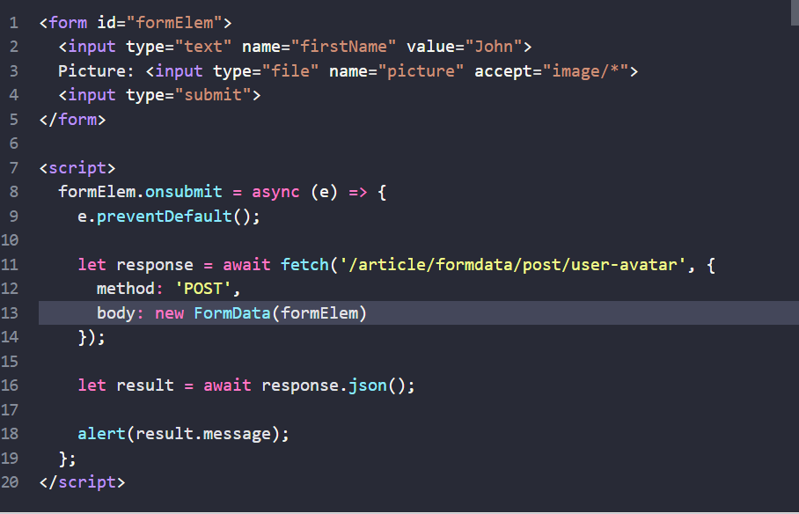

The purposes the validation form is: to obtain correct information and format and protect them. Validation in forms helps users put the correct data, but there are other ways to check these inputs too.

There is validation by the client side (browsers and javascript) and by the server, we can limit the characters numbers in one <input> or <textarea> using min e max, as well as determining if something is mandatory using required and the :valid and :invalid allow apply CSS one the valid datas and other to invalid datas.

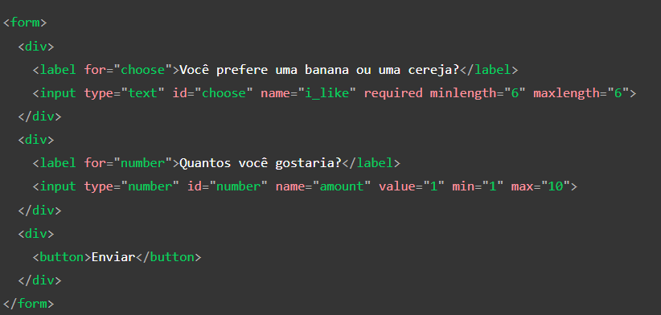

An attribute that is often used to determine and limit what can be typed is the *pattern* that expects a regular expression, more in information in [HTML attribute: pattern - HTML: HyperText Markup Language | MDN (mozilla.org)](https://developer.mozilla.org/en-US/docs/Web/HTML/Attributes/pattern)

